DML Exercise-2

Part 1 – Create Table
Create a table in your database named REPAIR that will have six fields as shown in the figure below. Use appropriate field data types and sizes based on the sample data. Don’t worry about constraints at this time.
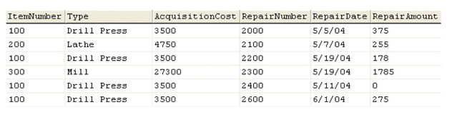

Part 2 – Insert the Data
Use the INSERT command to populate the table with the sample data. Remember the default Oracle date format.

Part 3 – Functional Dependencies and New Tables
Looking at the sample data you may have noticed that it is really representing two distinct entities. These entities can be expressed as functional dependencies. The two entities are:
- Item(itemNumber, type, acquisitionCost)
- ItemRepair(repairNumber, repairDate, repairAmount, itemNumber)
Create the two entities as new tables, make sure to create a primary key for each, and a foreign key for ItemRepair on itemNumber.write constraint.

Part4 – Commit
Commit the changes you’ve made.

